myStatus

Jake Bailey

rjacob@cs.washington.edu
Emily Chien
Computer Science & Engineering
University of Washington
AC101 Paul G. Allen Center, Box 352350
Seattle, WA 98195-2350
eechien@cs.washington.edu
Chuong Dao

chuongd@cs.washington.edu

ABSTRACT
We present myStatus, a mobile health app allowing clinicians to collect self-reported health data from patients without compromising patient privacy. While some solutions exist for collecting longitudinal health data from patients, they are cumbersome and require significant patient involvement. In patients dealing with clinical depression, severe problems can develop in the 2-8 weeks that pass between appointments. If clinicians could detect these problems as they happen instead of at the appointment (when they have already become a severe issue), recovery times may improve. The application presented in this paper provides a much easier to use and less intrusive interface for patients, while also protecting private information. myStatus is an Android application for taking surveys provided by physicians to self-evaluate their condition such as depression. Users get reminders about when to take the surveys so they don’t have to remember themselves. The long-term vision of the project is a general mobile health solution useful for more than just depression, which allows for a stronger line of communication between patient and clinician.

Categories and Subject Descriptors
General Terms
Keywords

INTRODUCTION
Among patients who have sought depression care, only 50% of those referred to a mental health professional follow through with that referral [4]. Many do not have more than one visit and 50-70% of patients do not have a full response to the first treatment plan. A significant part of treatment is that the patient has to be willing to be engaged but part of the reason for unwillingness is that the effort is too great when patients aren’t motivated. Our application seeks to enforce patient self-monitoring in a way that’s not intrusive to everyday activities and does not take an undue degree of effort.
The Patient Health Questionnaire [10] (PHQ-9) is a nine-question survey used by clinicians to monitor the severity of depression. To help clinicians be effective in their treatment, they ask their patients to fill these out at regular intervals. Instead of filling them out only when a patient comes in for an appointment, clinicians can have patients fill it out through our application. This then allows immediate help for managing symptoms or finding support.
Another issue clinicians see is that patients with prescriptions either always take them, refuse to take them, or want to but sometimes forget. Also, if a patient has multiple prescriptions it can be hard to remember what they look like. Users also do not want unwanted eyes seeing what prescriptions they are taking or even that they’re using an application to treat depression or some other condition. So our application has to keep their data secure. Figure 1 displays the login screen for users when they want to access the app.

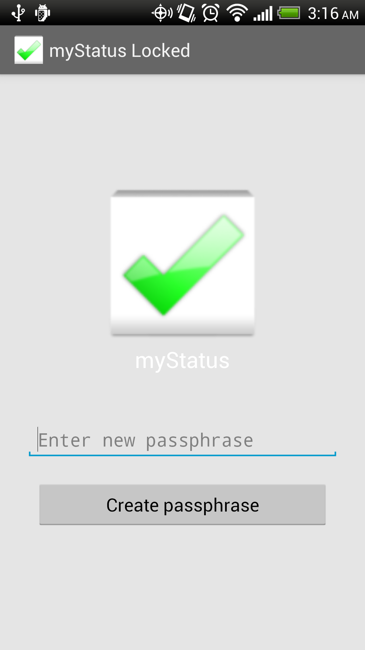
Figure 1: myStatus lock screen and start screen
The basic idea for our application is that users download surveys their doctors advise them to. By setting up reminders, users will be notified when there are surveys to take; some of which need to be taken once a day, once a week, etc. Our application keeps track of when surveys were last taken and determines which ones need to be filled out at the time of notification. Addressing the issue of prescription tracking, users can add their prescriptions and set up reminders. To keep the data secure and users safe from prying eyes, myStatus has a one-time password creation to discourage unwanted users from access. When there has been five minutes of inactivity, or the user navigates away from the application, it will lock. Notifications that can be seen without logging into myStatus, do not reveal anything about what the application is being used to treat. Figure 2 shows its main menu.

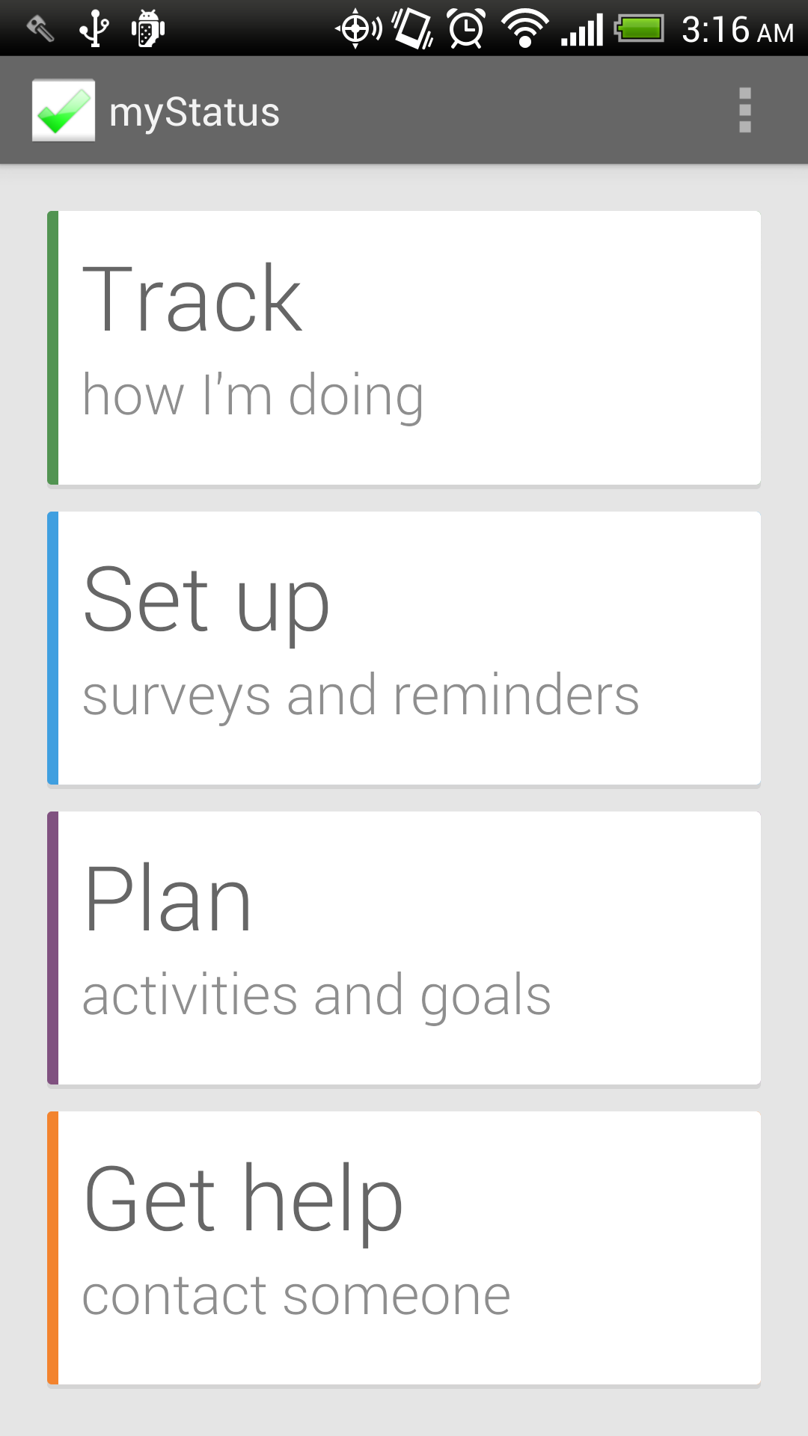
Figure 2: myStatus main menu

RELATED WORK
Patient self-management tools can be categorized as one of the following: subordinate, structured, collaborative, or autonomous [7]. Subordinate tools include home surveillance monitoring. Structured tools refer to notifications through other devices. Collaborative tools include online interventions and patient education materials. Autonomous tools do not require regular participation or physician input. Clinicians have mostly focused on collaborative tools thus far. Our current version of myStatus belongs more to the structured category based on taking surveys when prompted by notifications but because the survey data is sent to Aggregate it is also collaborative.

“PTSD Coach” [8] is a mobile application, which allows users to assess their state through a single seventeen-question survey. By taking that survey over a period time, a history is developed that the user can track. The user can manage symptoms, but this includes only a set of eight, which can be seen in Figure 3, all of which direct the user to the same sort of exercises in self-management such as deep breathing. Another feature it includes is finding support, either from crisis resources, personal contacts or professional care. They can also learn more about PTSD. One major drawback is that anybody looking through a user’s applications can see that the user is monitoring her depression, which could possibly lead to the user being harmed. Our application removes that risk not only with its name “myStatus” which could be for anything, but also by not revealing anything in the notifications either. By having a login requirement, we also reduce the risk of exposure.

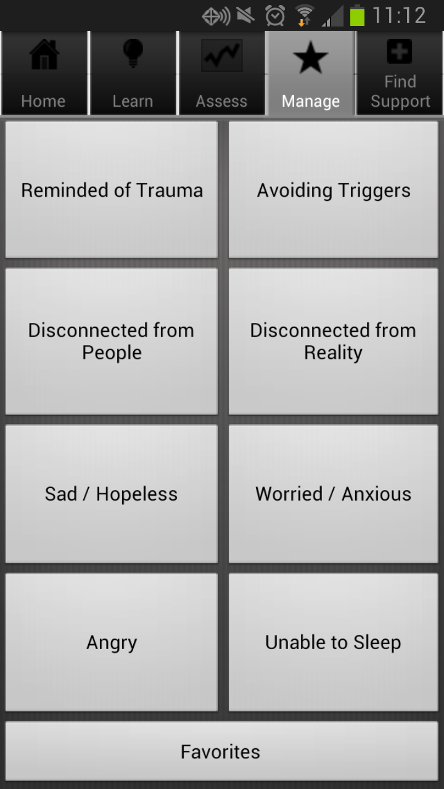
Figure 3: PTSD Coach symptom management
“eCBT Calm” [5] is an application that evaluates a user’s stress level through a series of questions and teaches them relaxation skills. While this is great for self-management, it provides no collaboration between a patient and physician. By sending survey data collected in myStatus to a server, physicians can track a patient’s progress along with them. This way if a patient does not follow through with appointments, physicians are, in a way, still in contact with their patient. Figure 4 shows an example of what a question would look like on eCBT Calm.

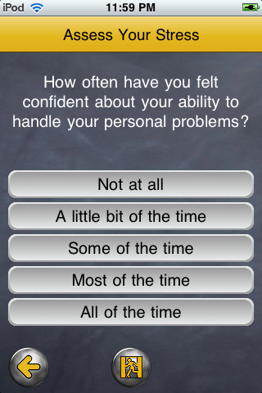
Fig. 4: eCBT Calm question sample
A different form of mental health monitoring applications includes headbands that monitor a user’s EEG connected to his mobile device [1]. While this would provide constant data from a patient it can be cumbersome. We want to give the user the least amount of reasons not to use our application. We want it to be subtle and quick but also provide aid when needed.

APPROACH

Existing Technologies Used
We designed our system with the goal of collecting information, storing it securely, and submitting it automatically to a dedicated server. For our solution, we chose several existing technologies appropriate for this design and integrated them with new components we developed. The myStatus components we engineered are described in the following section. The existing technologies we used, XForms, Open Data Kit, SQLCipher, CacheWord, and SpongyCastle, are described below.

XForms
XForms is a standardized XML format for specifying form data and appearance. XForms provides a relatively simple data processing model that makes it easy to describe common data manipulation tasks, including constraints on inputs, calculation based on inputted data, and branching logic. The XForms format is also the one used by Open Data Kit, which provides an easy-to-use, Excel-based XForms specification tool called XLSForm.

Open Data Kit
Open Data Kit (ODK) [2] is a free and open source set of tools designed as solutions for mobile data collection. Our application is based on ODK Collect, an Android application used for rendering surveys, collecting data, and submitting collected data to a server. Using an existing data collection tool allows us to support rich and complex forms that we would otherwise not have been able to support. Embedded media, branching logic, and a variety of data entry widgets can give clinicians a great deal of freedom in creating surveys for their patients. Since Collect is designed as a tool for researchers, it provides a lot of options and settings not necessary for our use case, and our system attempts to streamline the application for use by patients.
We also make use of ODK Aggregate, a server and data repository in the ODK tool set. Using ODK Collect's components, our application can download surveys from and upload survey responses to the Aggregate server. Aggregate also provides a web interface with data visualization and export tools. For our solution, Aggregate serves as the clinician interface, allowing clinicians to make surveys available to patients and review submitted patient data.

Security Libraries
Due to the fact that myStatus contains health-related patient information, security is a major concern. myStatus stores data in two formats: SQLite databases (for form and submission metadata) and files in the /sdcard directory of the Android device (for forms and form media). Since this directory is unprotected, anyone with a micro USB cable and ADB (Android Debugging Bridge) installed on their computer can view all myStatus data with a few Linux and sqlite3 commands. In addition to protecting the raw data, our solution needed to involve a method of ensuring that only the patient could access their data through the application’s front-end.

SQLCipher [9] is an open-source library for database encryption, which provides transparent 256-bit AES (Advanced Encryption Standard) in CBC (Cipher Block Chaining) mode. Our application makes use of this library to encrypt all SQLite databases. With this feature, anyone who has access to the device through ADB can no longer retrieve information from myStatus databases without the user's key.

In order to access these databases, our application needed to store a key derived from a user login password. We decided to use the CacheWord library provided by the Guardian [6] project for maintaining and providing this key. The primary features of this library are strong key derivation using PKDF2 (Password-Based Key Derivation Function 2) and highly secured storage using AES-256. In addition, this library also provides a configurable timeout, which is used by myStatus to lock the app after a certain amount of idle time, at which point the user is prompted to type in their password again.

Lastly, myStatus uses the SpongyCastle [11] library for encrypting media files as well as form XML files. The SpongyCastle library can make use of the derived secret keys provided to it by the CacheWord service to encrypt and decrypt files. Even if a curious user has access to the Android devices and uses ADB pull to get the media and xml files, they cannot see, watch, or listen to them at all since the files are encrypted.
The time for encryption and decryption can be lengthy for large files and each file must be decrypted before being used, so we create a folder for storing temporary decrypted files, which can be reused for a certain amount of time. When the timeout is signaled from the CacheWord service, all the data in the temporary folder is removed before the application locks. In general, all files stored by myStatus are encrypted, and a correct password is required to get the derived key for decryption.

Architecture
Our application, being based on ODK Collect, uses the same model for data collection and aggregation as Collect and Aggregate, as shown in Figure 5. Namely, the mobile application downloads surveys from Aggregate and submits survey responses automatically, while the Aggregate web interface allows clinicians to view and visualize submitted data. What differentiates our application from Collect is its simplified interface, its ability to generate notifications when relevant, and its additional tools for patients with chronic medical conditions.

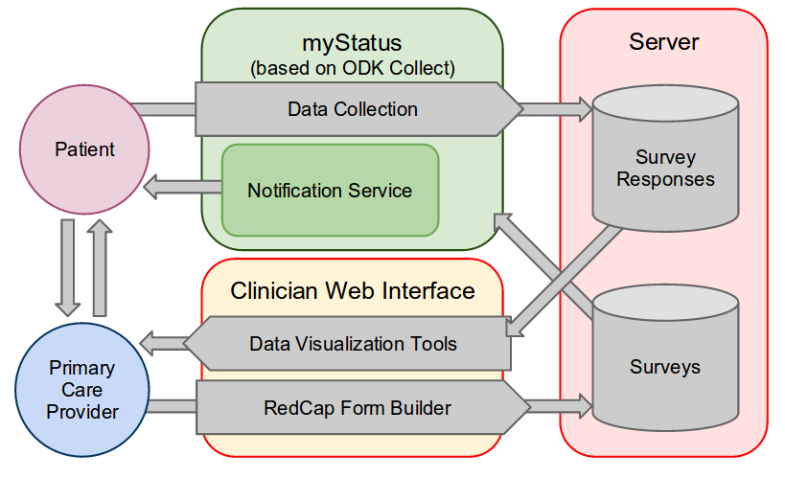
Figure 5: myStatus downloads surveys from a server such as ODK Aggregate, notifies the user to fill out surveys, and submits survey responses to the server, where they can be viewed by clinicians

Data Collection
The primary feature of the application is the ability to collect status information from patients. Our solution for collecting data from patients was to use ODK Collect's form entry components, but since Collect is not designed for longitudinal data collection, it provides no mechanisms for managing what surveys need to be responded to and when. Since some forms are only relevant after a given period (the PHQ-9, for example, is intended to be given no more frequently than every two weeks), we provide notifications that alert the user when surveys are due, and a method of specifying when a survey needs to be responded to.
Since our application needs to be as unobtrusive as possible, we give the user control over when they would like to receive notifications. myStatus allows users to set which days of the week they would like to receive a notification, and what time of the day would be convenient (Figure 6). At these times, the application determines whether any surveys are due, and if so, generates a notification. The notification includes a snooze option, so if the user is busy at the time they set, they can temporarily dismiss the notification and be reminded again shortly after.

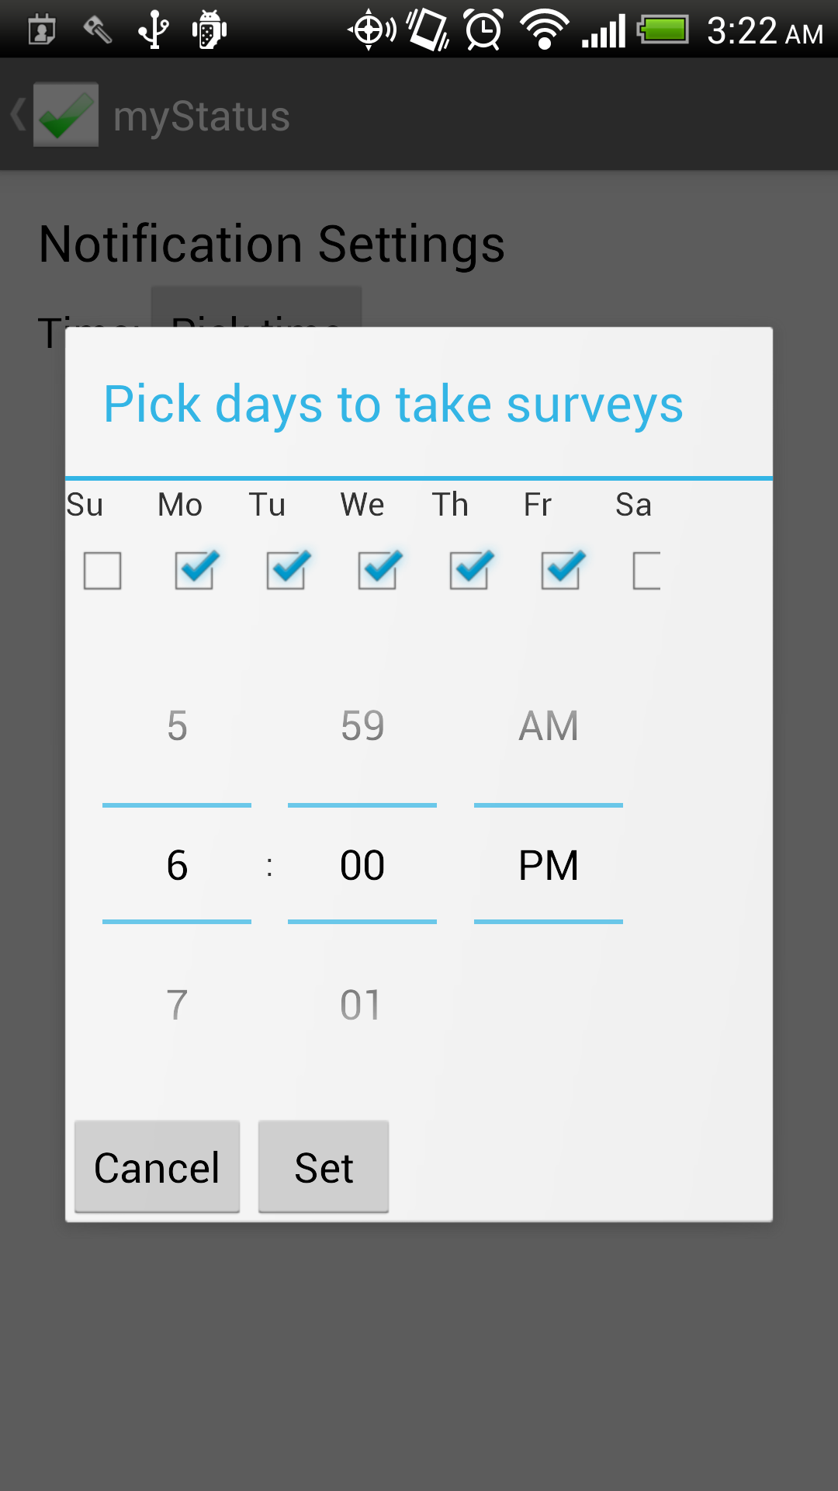
Figure 6: Users can specify what time of day and what days they would like to receive a notification about due surveys.

The notion of when a survey is due is determined by a survey's predicate, an attribute we add to the data model of myStatus XForms, which is not part of the XForms standard. The predicate is one of a few simple expressions indicating when the survey needs to be responded to. For example, the predicate for the PHQ-9, which is relevant at most every two weeks, is "daysSinceLastResponse:14". Also supported are predicates for once-only surveys (for unchanging information like medical history) or delayed surveys (for information that will only be available in the future, like future parts of a longitudinal survey).

Clinician Interface
Our system has made no improvements on the interface already provided by ODK Aggregate and other ODK tools. In its current state, the system requires clinicians to develop forms using ODK Build or XLSForm, upload them to Aggregate, and view survey responses using Aggregate's data visualization tools. Clinicians can also use Aggregate's export features to download all collected data as a CSV file.

Prescription Reminders
Patients who take a large number of prescriptions or have trouble remembering to take medications could make use of a pill reminder application. While such applications exist, they don't provide the privacy or security that myStatus provides. Integrating these reminders into our application prevents exposure of potentially sensitive data regarding a patient's pill regimen.
For each medication, a patient can record the medication type, take a photo, and set reminders. Each reminder (after the user has bypassed the lock screen) displays the recorded information about the medication and the quantity to be taken.

IMPLEMENTATION

4.1 Motivation for Modifying ODK Source Codes
At first, we tried to implement myStatus using ODK Collect as a foundation library. However, we faced some difficulties in utilizing Collect without modifying it. For instance, it is a challenge to encrypting all of the forms and media files efficiently because ODK Collect specifies a fixed location for storing all the forms and data. Therefore, by modifying the source code, we can make the application encrypt all the data and store the encrypted versions instead. In order to make our application generate notifications based on the last completion time, we needed to access and add extra information to the database of the XForms survey. It was also difficult to add support for longitudinal studies in the future. Using ODK Collect as a library caused some unexpected interference with the original ODK Collect application, therefore, we decided to modify ODK Collect source code and integrate it with the myStatus source code. While modifying the open-source ODK project, we tried to make minimal changes as well as modularize our changes so that it is easy to contribute back to the original project.

4.2 Notification Generation and Due Surveys List
One of the major functionalities of myStatus is the ability to generate notifications based on user configuration and survey types (daily survey or one-shot survey) and to generate reminders that help users manage their prescriptions. We also learned that the way notifications are generated should be friendly to the user because they do not want to be bothered too many times. We looked into different applications in the market for different models for notifications such as allowing users to set notification times that will then show up as calendar events in the Google Calendar application for Android devices. Another model we considered is allowing users to set multiple notification times per day of the week either before or after work. However, after a discussion with Dr. Amy Bauer, psychiatric at University of Washington medical center and also our client for this project, about these ideas, we decided to simplify our notification model, which now permits users to set one time of the day and choose which days of week they would like to receive the notification. This has the disadvantage of requiring that notifications always arrive at the same time, but we decided that having a "Snooze" button on notifications was a sufficient compromise. Also, the “Dismiss” button appears with the generated notification, which keeps myStatus from re-generating the notification for the day. In order to make the notification generate at the appropriate time, we implemented our own model which allowed the user to specify some conditions: days between responses to a periodic form (e.g. PHQ-9 should be responded to every 14 days, one-off forms (first time setup, feedback surveys) and forms with a time delay. Figure 7 shows how user pick specific days and a specific time they want to take the surveys so the notification can only be generated during that time. Figure 8 below illustrates how the notification looks with the two buttons Snooze and Dismiss. By clicking on the notification the user would be redirected to the list of surveys that needed to be completed.
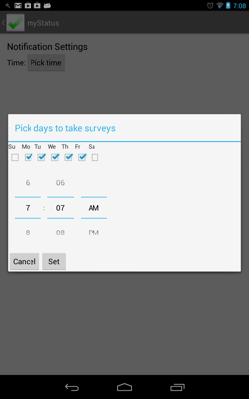
Figure 7: Time picker for setting up survey notifications

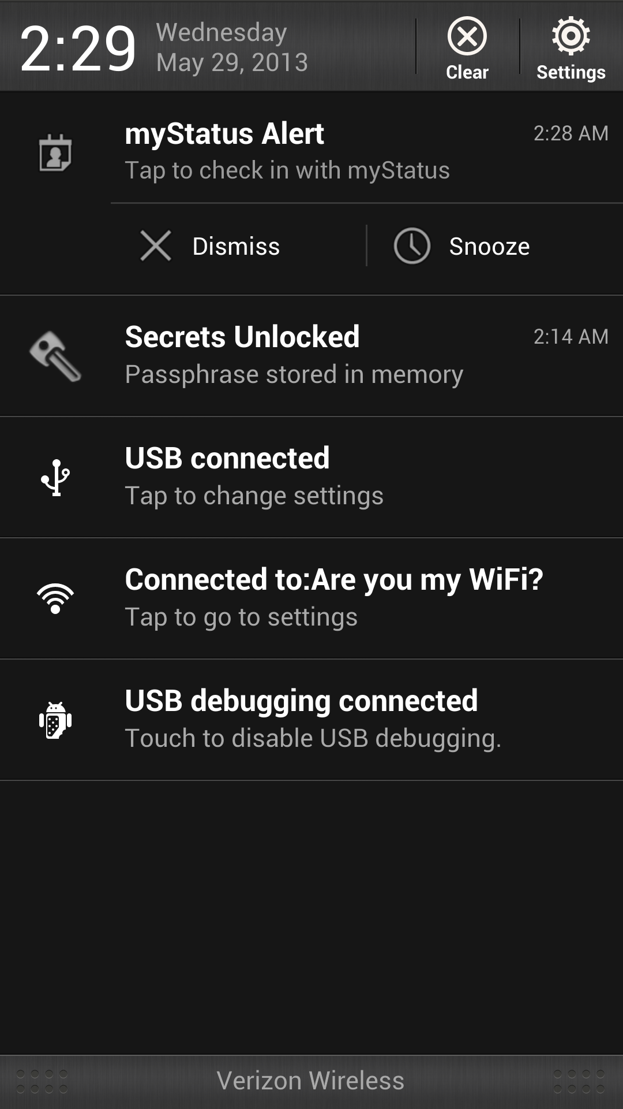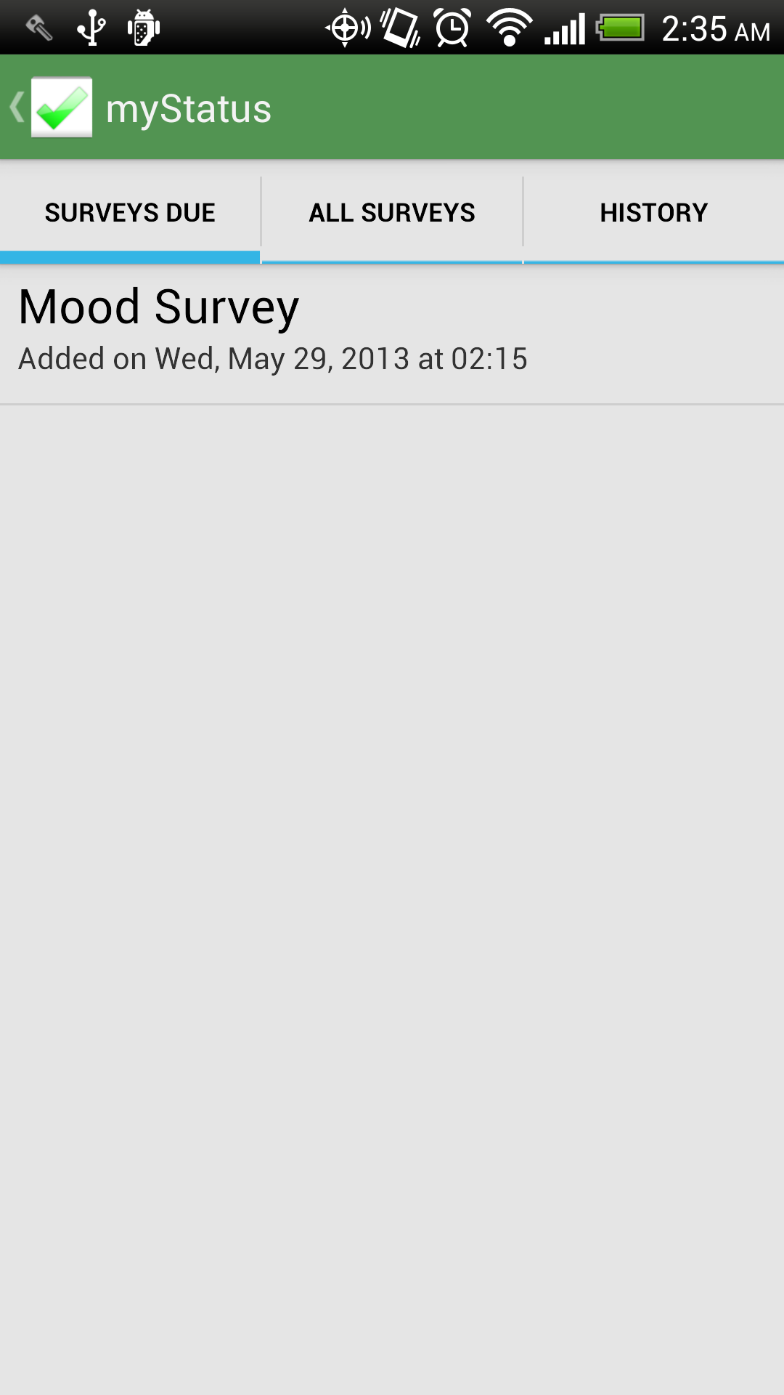
Figure 8: Notification and Due Survey list

Clicking on one of the due surveys on the list will prompt the user through the process of answering all the questions in the surveys as in figures below. Also, the completed forms will automatically send it to the ODK Aggregate server specified in the URL setting page of ODK Collect. Figure 9 displays some sample questions of a surveys that user will get prompted to answer.
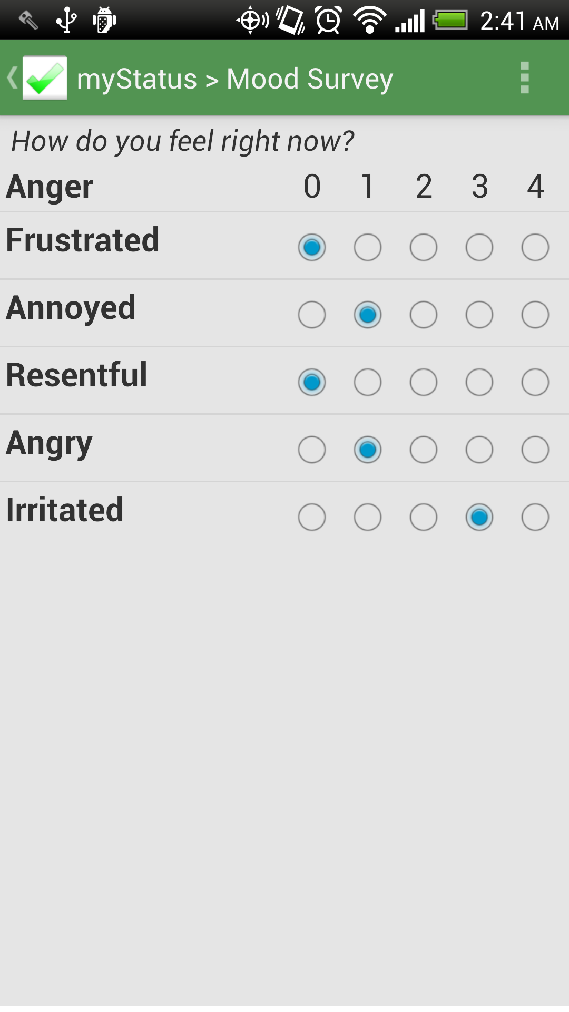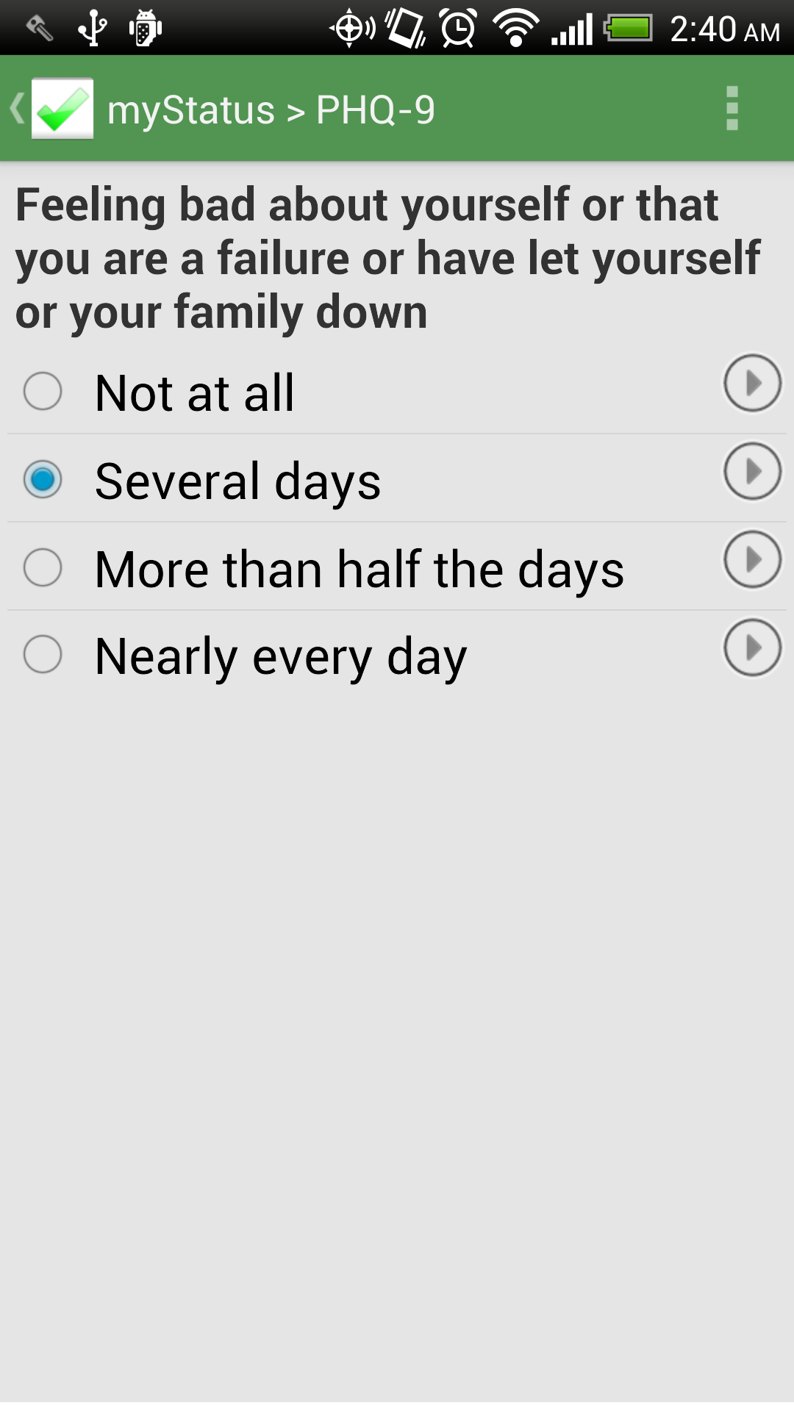
Figure 9: Sample Survey Questions

4.3 History View
We also added a history feature, which allows users to view all of the surveys they have completed as well as the status of them such as incomplete or submitted. The information in the surveys can be summarized in tabular format, which helps users keep track of their records. Figure 10 shows the example of how different instances of a specific survey are displayed with various submission statuses. By clicking on the View Table button users will be prompted to a table, which displays all the data has been filled in as in Figure 11. Therefore, users can easily follow the progress of specific attributes or scores in the survey.
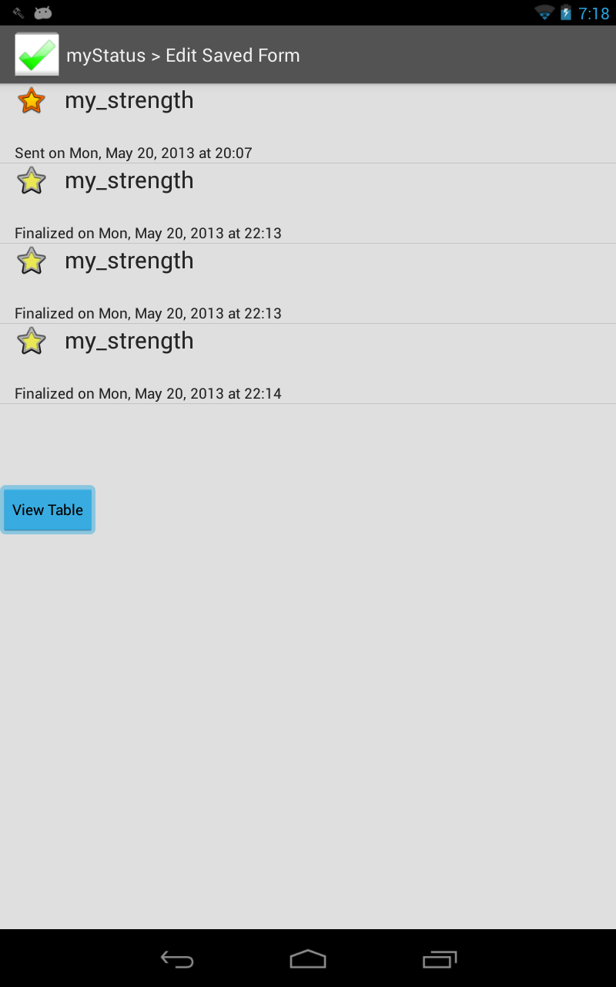
Figure 10: History view of a specific form

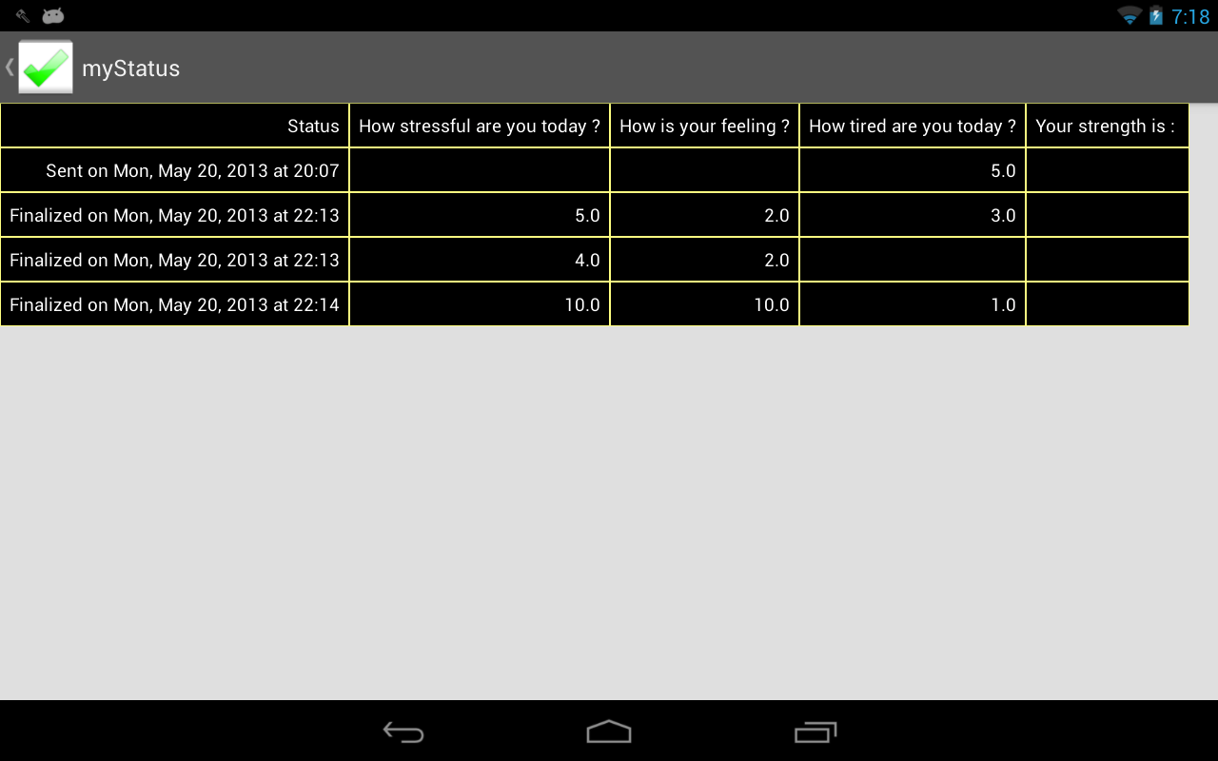
Figure 11: History view in tabular form

4.4. Prescription Management
Besides these basic features, we also added an extra feature that helps users manage their own prescriptions. This feature allows users to take a picture of their medication, and set a time for a reminder to take it. Figure 12 is an example of the list of prescription and Figure 13 displays a detailed of a specific description.
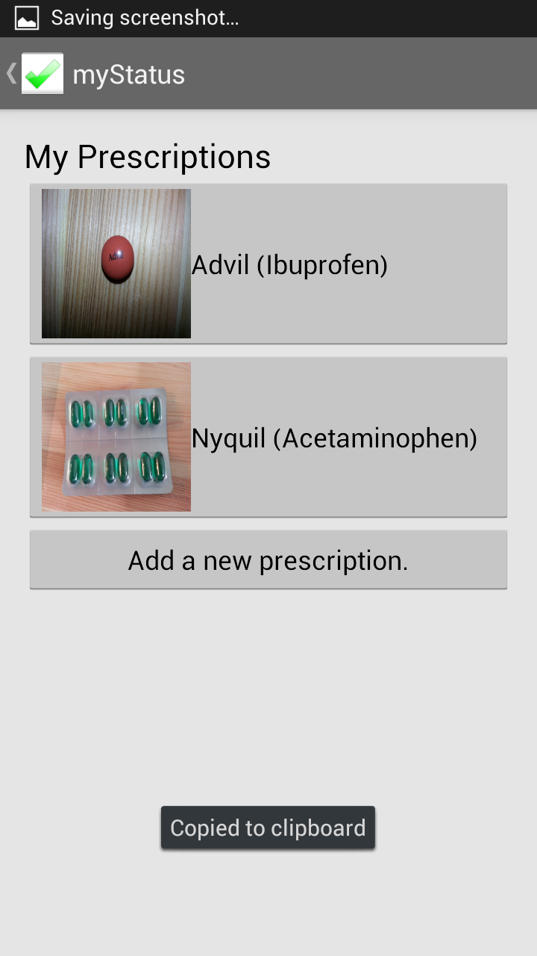
Figure 12: Manage prescriptions view

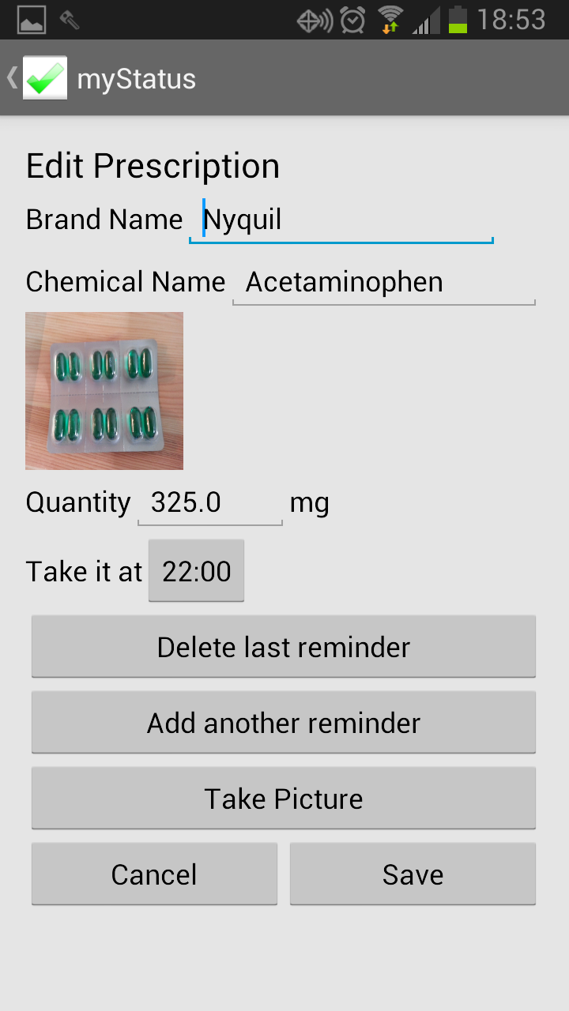
Figure 13: Edit prescriptions view

4.5 Get Help
Lastly, we added a help page to myStatus, which allows users to call their clinician and friends in order to ask for quick advice or for sharing uneasy feelings. Figures 14 lists out some current available options.
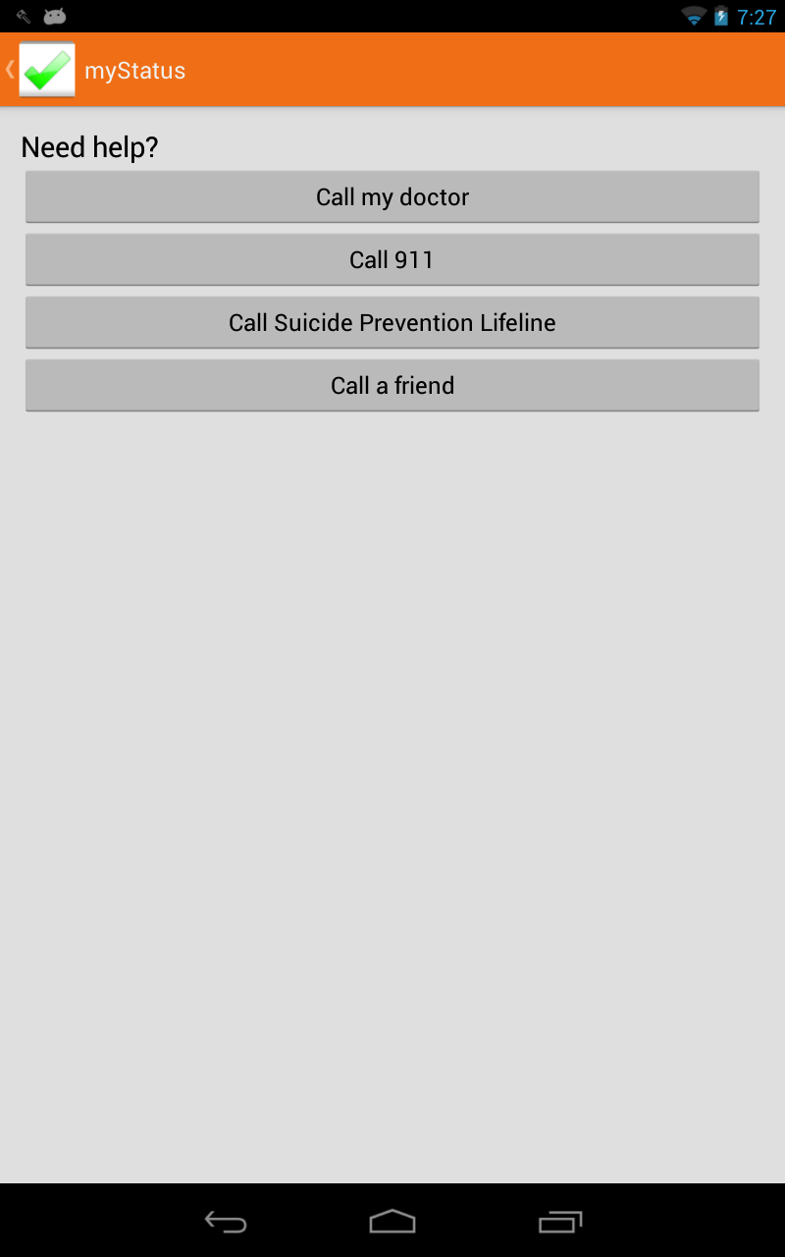
Figure 14: Get Help page
4.6 Encryption
We used the SQLite Cipher library to encrypt our database using the derived key from the user password. Figure 15 shows how information of a normal database in Android can be viewed using the SQLite command dump by connecting the mobile device to a computer through the Android Debugging Bridge (ADB). On the other hand, Figure 16 shows how an encrypted database cannot be exposed using the similar method.

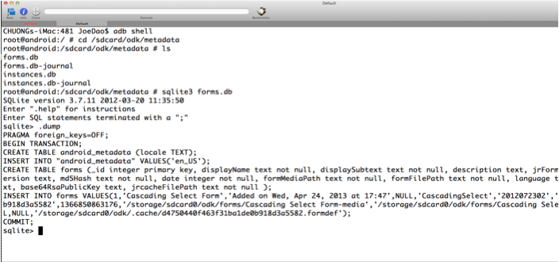
Figure 15: Without SQLite Cipher encryption for database – data is exposed
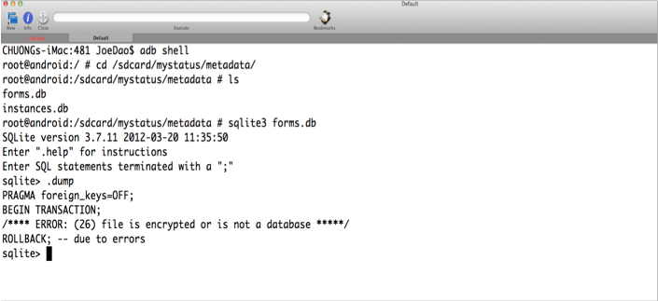
Figure 16: With SQLite Cipher encryption for database – data is not exposed

In a similar way, the Spongy Castle library provided a mechanism for encrypting XForms and media files. Figure 17 shows how content of an XForm, which represents a specific survey, can easily be displayed via ADB while Figure 18 illustrates how an encrypted version of an XForm is stored instead of the original content.

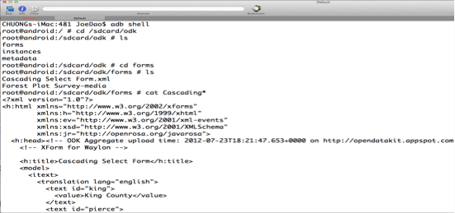
Figure 17: XForms without encryption

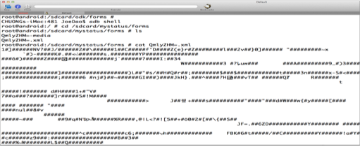
Figure 18: Adding encryption to XForms

Similarly for media files, as we can see in Figure 19, we can easily transfer any media files stored in the mobile devices to our own computer via the pull command provided by ADB and examine the content using supported software. By adding encryption, users using ADB pull can only get an encrypted version of the media files which cannot be explained by other software without decryption (Figure 20).

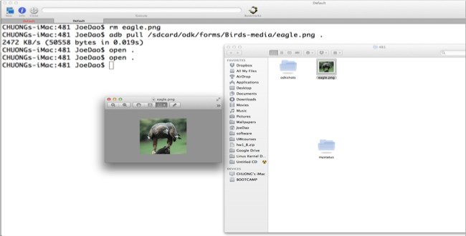
Figure 19: Pulling encrypted image data

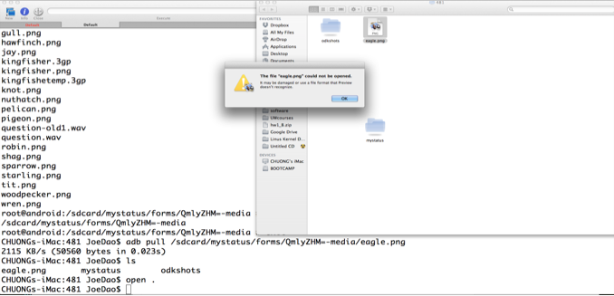
Figure 20: Pulling encrypted image data – cannot be viewed

We also encrypted the name of the XForms to prevent exposed content of the surveys. One of the limits of our encryption method is that we cannot encrypt the name of the media files of specific surveys because the names of the media files are specified in the content of the XForms. A temporary solution is to let the survey maker know this limitation so that they could name the media files in some manner that would keep the information more secretive.

Moreover, the time for decrypting a large media files can be lengthy, so we created a folder for storing temporary decrypted files, which can be reused for a certain amount of time. After a long idle time of losing focus or the mobile device screen turned off, CacheWord service would send a timeout signal to myStatus, which would cause all the data in the temporary folder to be wiped out and the app to be locked.

EVALUATION
We did not have time for user testing during this quarter but we were able to get feedback while working with Dr. Bauer. Her main goal was to have the needed features she saw in other applications like the “PTSD Coach” and make sure they were exposed to the user in reasonable ways.

In terms of qualitative feedback, were we to go on with user testing, we would have to use surrogate users such as students and not real patients because of the lack of HIPAA Compliance. We would ask users whether they found the log in and encryption intrusive to their experience. We would also like to know if there was more information they’d like to get in their notifications.

In terms of quantitative data, we want to know if encryption is efficient and if access to the databases is efficient as well.

CONCLUSION AND FUTURE WORK
Continuing with this project we’d hope to add features for collaboration between patients and physicians. Physicians should be able to directly add which surveys to take to the app so that patients who may forget what their provider suggested do not need to find them. We would also like to see direct communication between the physicians and patients through the application.

Added features for self-management would include activity planning and goal setting. By encouraging the user to make plans to go out or get exercise, our application would promote symptom treatment. If the information was submitted to Aggregate so that the providers could see what activities were planned and accomplished the provider could track patients’ progress that way too.

For our history page we would like to see a graph of progress over time instead of the table. This way, users could see only the information needed to check their status. With surveys like the PHQ-9 only the final result is necessary to track improvement because the score is based on the total from the questions asked.
Currently there are a lot of setup details that aren’t obvious to users. A first time use walk through would help the user see these features. For example, they need to let the application know when a good time to be notified about surveys are and they should be notified about the length of time of inactivity the app allows before it is locked. The walk through could also guide them through the prescription management.

Were we to do this over, we would have cut out the security aspect of myStatus. This way we could focus on the collaborative side to deal with patient-physician communication. Security took up a good deal more time than anticipated and that time could have been used for giving the app more features that contribute to self-management. Securing patient data is always important but for the time frame we had it should not have been a priority.
At the beginning of the project when we tried to use ODK Collect as a library, we learned that with the way we were using it, making changes in it because we needed the data encrypted, this was not possible. Instead we had to make the least amount of changes possible to keep it reusable in case the writers of ODK Collect wanted to use our material.

myStatus is meant to be a mobile app encouraging collaboration between patient and provider while also allowing the patient to self-manage their condition. While our app lacks much of the collaboration we anticipated having, future work would prove it to be useful for these measures. Even without these features though, our app is better than what is already out there because of the prescription management and security, which other applications do not have.

ACKNOWLEDGMENTS
We would like to thank Amy Bauer for her help with the design of our application. We would also like to thank Gaetano Borriello, Ruth Anderson, and Rohit Chaudhri for their instructional aid and input.

REFERENCES
- Bong, Kyeongryeol, Hyunwoo Cho, Sunjoo Hong, Taehwan Roh, and Hoi-Jun Yoo. "Wearable Mental-health Monitoring Platform with Independent Component Analysis and Nonlinear Chaotic Analysis." IEEE Xplore. Korean Adv. Inst. of Sci. & Technol. (KAIST), Daejeon, South Korea, 28 Aug. 2012. Web. 03 June 2013. <http://ieeexplore.ieee.org/xpl/articleDetails.jsp?tp=&arnumber=6346977&url=http%3A%2F%2Fieeexplore.ieee.org%2Fxpls%2Fabs_all.jsp%3Farnumber%3D6346977.>
- Borriello, Gaetano, Nathan Breit, Waylon Brunette, Rohit Chaudhri, Nicola Dell, Sam Sudar, and Mitch Sundt. Open Data Kit. Computer software. Open Data Kit. N.p., 2009. Web. 12 June 2013. <http://opendatakit.org/>.
- "Block Cipher Mode of Operation." Wikipedia. Wikimedia Foundation, 06 Jan. 2013. Web. 03 June 2013. <http://en.wikipedia.org/wiki/Block_cipher_mode_of_operation#Cipher-block_chaining_.28CBC.29.>
- Dr. Bauer, Amy. Personal interview. May 2013.
- ECBT Calm. Computer software. Mind Apps Llc, 20 Jan. 2011. Web. 03 June 2013. <https://itunes.apple.com/us/app/ecbt-calm/id356997070?mt=8>.
- Freitas, Nathan. The Guardian Project: Secure Mobile Apps and Open-Source Code for a Better Tomorrow. The Guardian Project. N.p., 2009. Web. 12 June 2013. <https://guardianproject.info/>.
- Michael, Barrett J. "Patient Self-Management Tools: An Overview." Critical Mass Consulting, June 2005. Web. May 2013. <http://www.chcf.org/~/media/MEDIA%20LIBRARY%20Files/PDF/P/PDF%20PatientSelfManagementToolsOverview.pdf>.
- Mobile App: PTSD Coach. National Center for PTSD. United States Department of Veteran Affairs, Mar. 2011. Web. 03 June 2013. <http://www.ptsd.va.gov/public/pages/ptsdcoach.asp>.
United States. Agency Medical Directors' Group. The Patient Health Questionnaire. Pfizer, 1999. Web. <http://www.agencymeddirectors.wa.gov/Files/depressoverview.pdf>
- SQLCipher. Computer software. SQLCipher. Zetetic LLC., Nov. 2008. Web. May 2013. <http://sqlcipher.net/>.
- "The Patient Health Questionnaire." Agency Medical Directors' Group. Pfizer Inc., 1999. Web. 12 June 2013. <http://www.agencymeddirectors.wa.gov/Files/depressoverview.pdf>.
- Tyley, Roberto. Spongy Castle. Computer software. Spongy Castle. N.p., 2013. Web. 12 June 2013. <http://rtyley.github.io/spongycastle/>.

